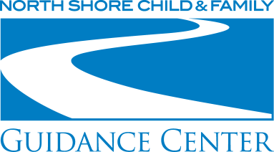

PURPOSEFUL USE OF ACTIVITIES IN GROUP WORK WITH CHILDREN AND ADOLESCENTS
FRIDAY, June 29, 2018, 9:15 a.m. - 12:15 p.m.

Fees: ___ $65 Registration including Social Work CEUs

___ $50 Registration without CEUs, including students

For Social Workers: please indicate whether you are a __LMSW or __LCSW and your license # ____________

For Mental Health Counselors: please indicate your license # ____________

Training Date:

___ Friday, June 29, 2018 – Purposeful Use of Activities in Group Work

Name: ____________________________________________________________________________________

Organization: _______________________________________________________________________________

Address: ___________________________________________________________________________________

City: _____________________________________________ State: _________ Zip: _______________________

Phone: ____________________________________________________________________________________

Email: _____________________________________________________________________________________

Credit Card Number: _________________________________________________________________________

Card Type: __________________________ Exp. Date: _________________ Total Amount to Charge: $_______

Check #: ___________ (Please make checks payable to NSC&FGC)

To register by mail, please send this form to:
NSC&FGC Development Department
480 Old Westbury Road
Roslyn Heights, NY 11577

Questions?
Please call or email Nicole Oberheim at
(516) 626-1971 ext. 337 or noberheim@northshorechildguidance.org.

